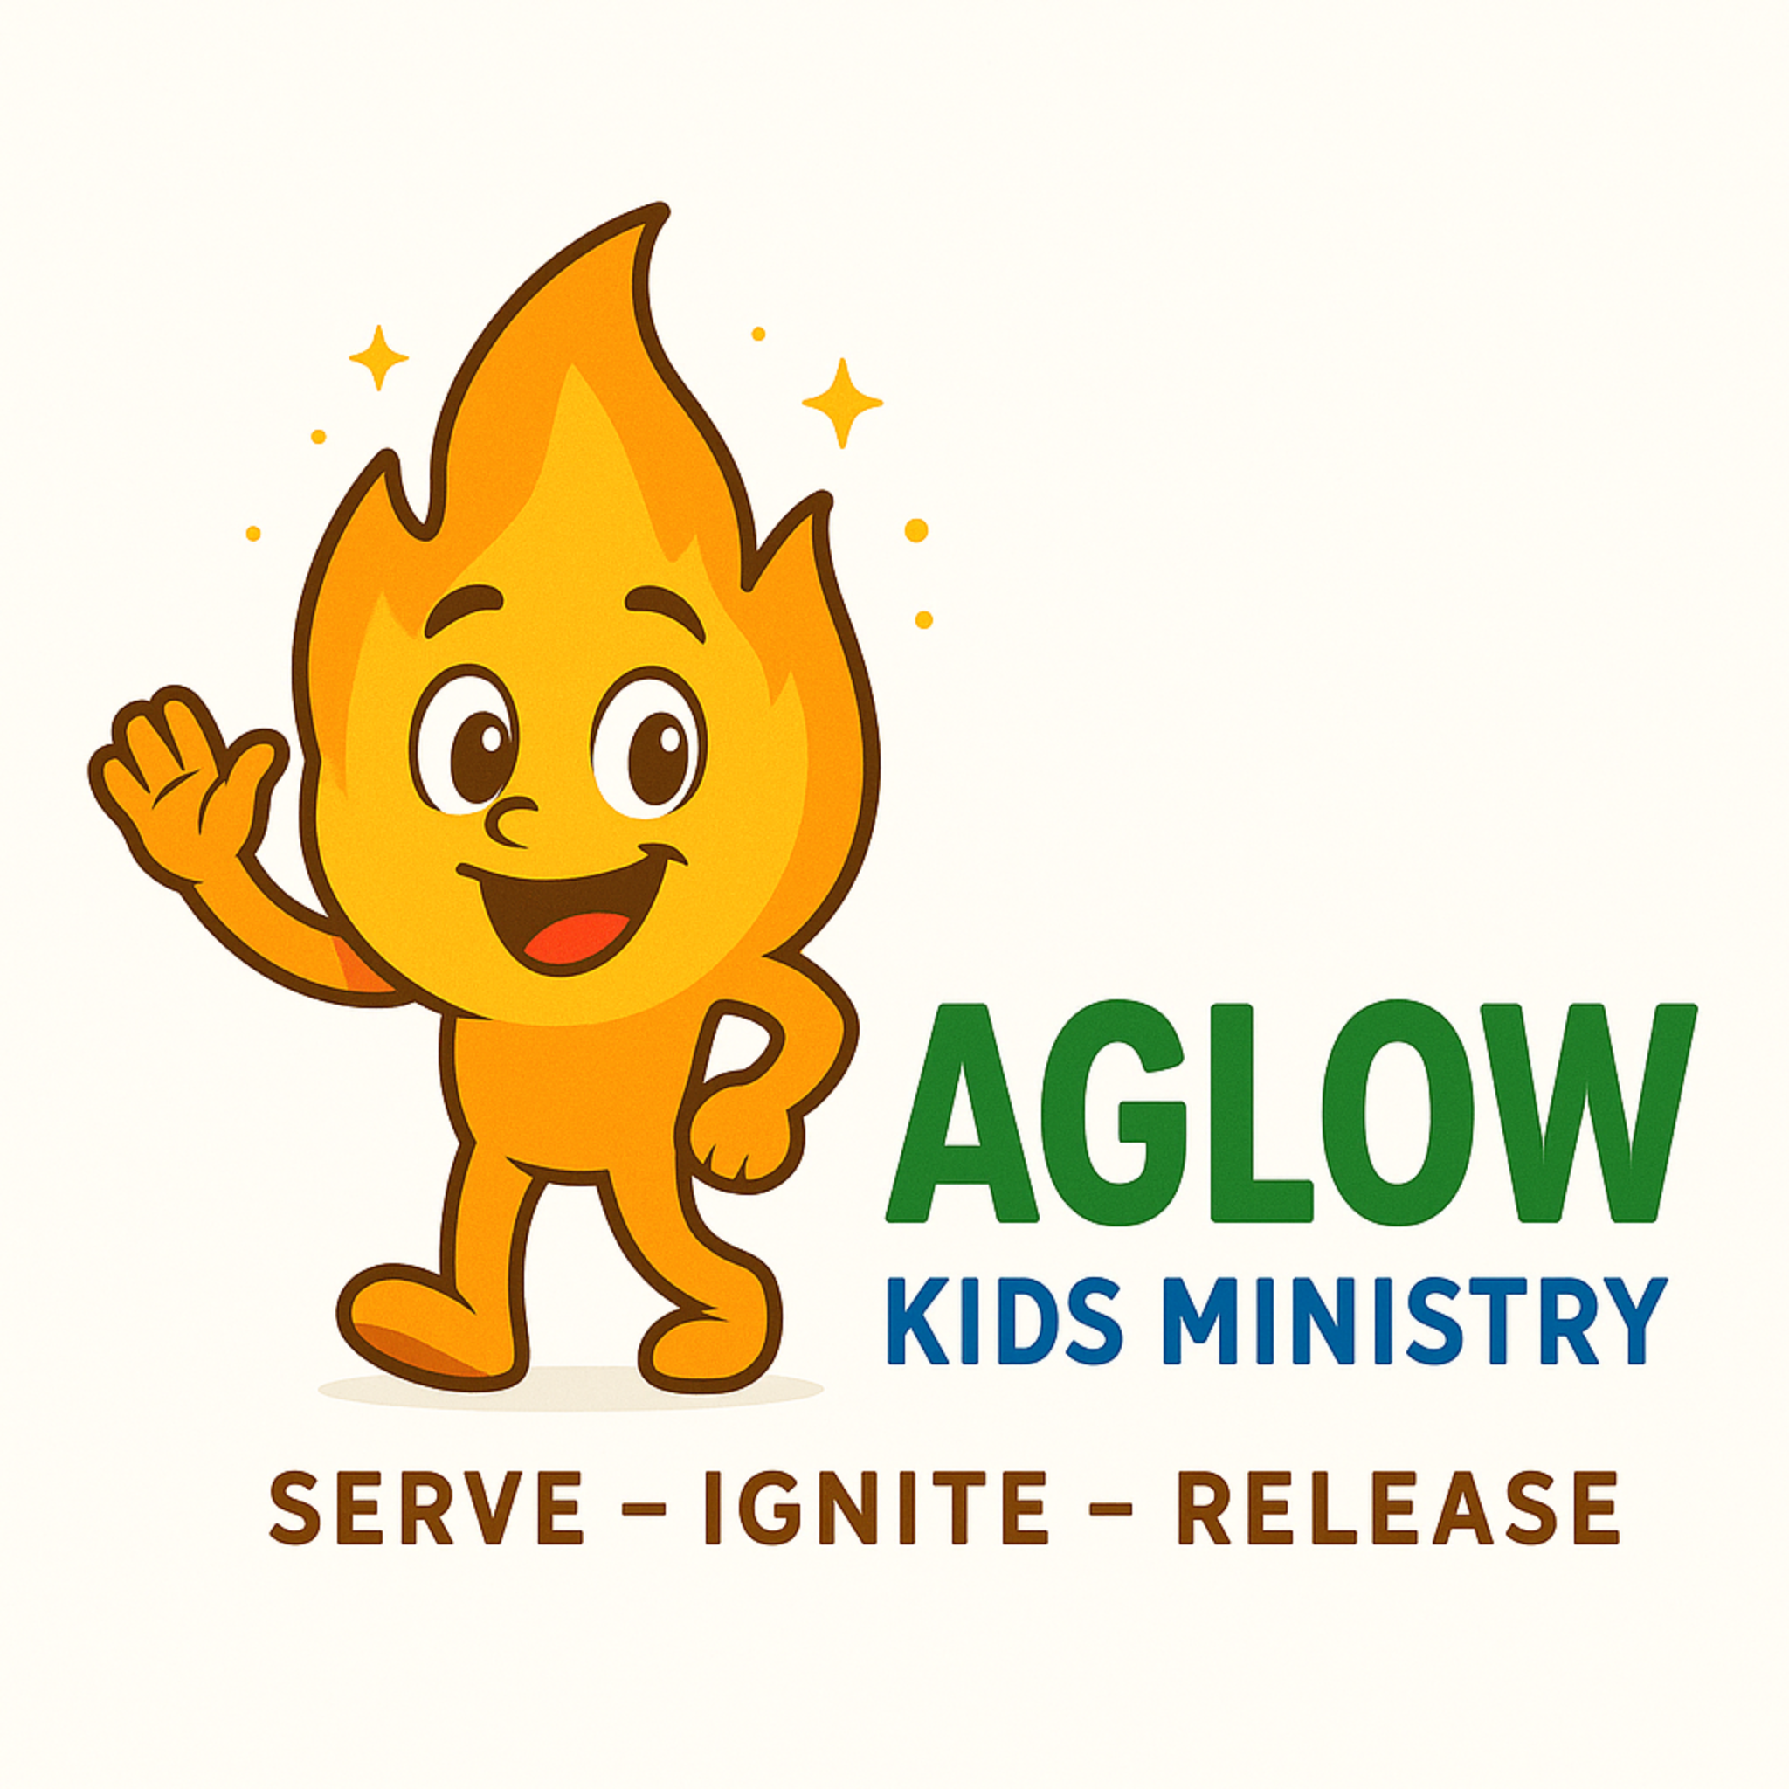
Aglow Kids Ministry
Child Registration & Consent Form
Park Harbor Church
1615 Texas Ave S
St. Louis Park, MN 55426
Child Information
Child’s Name: ______________________________
Date of Birth: ______________________________
Age: ______________________________
Gender: ______________________________
Address: ______________________________
Parent/Guardian Information
Parent/Guardian Name: ______________________________
Phone: ______________________________
Email: ______________________________
Authorized Pickup
Authorized to pick up child: ______________________________
Not authorized to pick up child: ______________________________
Medical Information
Allergies: ______________________________
Medications: ______________________________
Medical Conditions: ______________________________
Emergency Contact
Name: ______________________________
Relationship: ______________________________
Phone: ______________________________
⚠️ For your child’s safety, children will only be released to an approved parent or guardian. Photo ID may be requested if the individual is not recognized.
Consent & Release
I give permission for my child to participate in Aglow Kids Ministry activities. I understand that all reasonable safety precautions will be taken. I agree to partner with the ministry and release Park Harbor Church and its volunteers from liability.
Signature: __________________________ Date: __________
Photo Release
I give permission for photos/videos of my child to be used for ministry purposes.
Signature: __________________________ Date: __________

