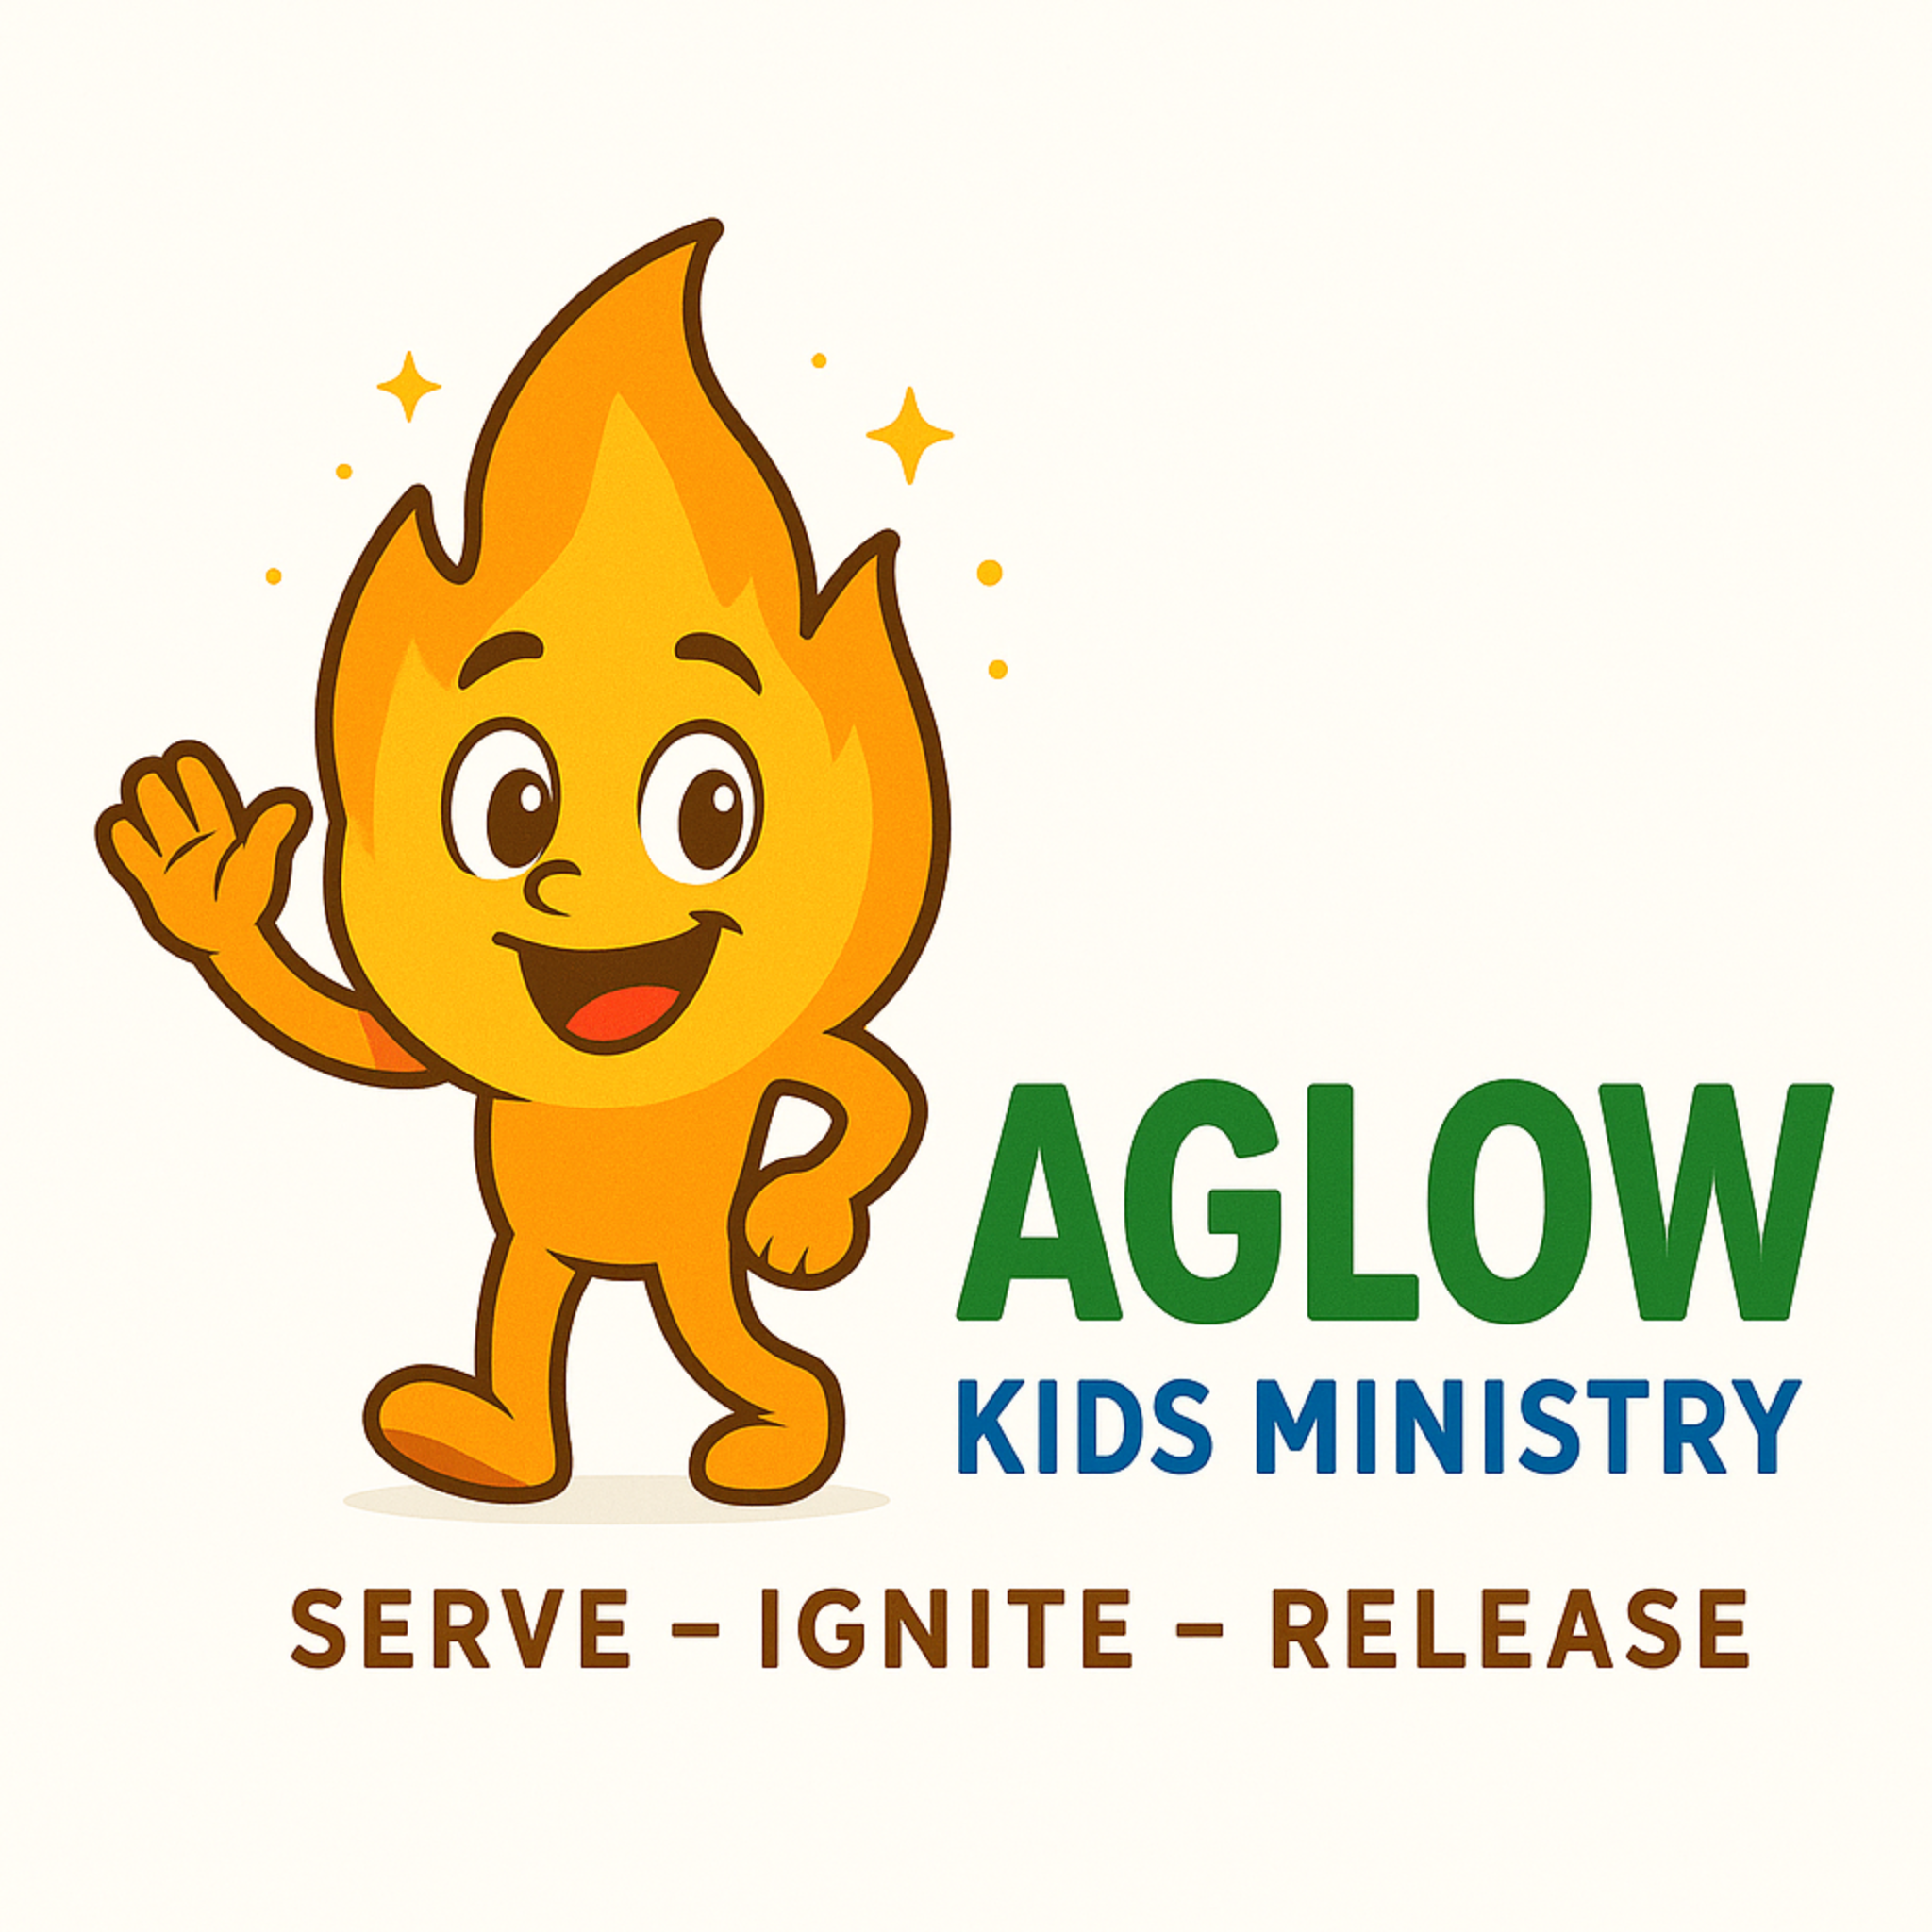
Aglow Kids Ministry
Special Needs Support Form
Park Harbor Church
1615 Texas Ave S
St. Louis Park, MN 55426

🌿 Our Heart
Every child is seen, known, and deeply valued.
This form helps us partner with you to better understand your child and create a safe, supportive, and positive experience while they are in Aglow Kids Ministry.

👤 Child Information
Child’s Name: _______________________________________
Date of Birth: _______________________________________
Age: ___________
Parent/Guardian Name(s): _______________________________________
Phone: _______________________________________
Email: _______________________________________

🩺 Medical Information
1. Does your child have a specific diagnosis or condition?
☐ No
☐ Yes (please describe in simple terms):

2. Is your child taking any medication we should be aware of?
☐ No
☐ Yes (name and possible side effects):

3. Does your child experience seizures?
☐ No
☐ Yes – Controlled
☐ Yes – Uncontrolled
If yes, please describe frequency and what to do:

4. Does your child have respiratory concerns?
☐ No
☐ Yes (please describe):

5. Does your child have any allergies?
☐ No
☐ Yes (please list):

6. Foods or drinks your child should NOT have:

🍽️ Daily Care Needs
7. Does your child need assistance eating or drinking?
☐ No
☐ Yes (please describe):

8. Toileting:
☐ Independent
☐ Wears diaper/pull-up
☐ Needs assistance (please describe):

9. Any additional care instructions we should know:

🗣️ Communication
10. How does your child communicate?
☐ Non-verbal (vocalizes)
☐ Uses words
☐ Speaks in short phrases
☐ Speaks in full sentences
☐ Other: _______________________________________

11. Hearing needs:
☐ None
☐ Hearing aid
☐ Uses sign language
☐ Other: _______________________________________

12. Vision needs:
☐ None
☐ Yes (please describe):

🤝 Social & Behavioral
School: _________________________
Grade: ___________

13. Does your child receive special education services?
☐ No
☐ Yes
If yes:
☐ Full inclusion
☐ Partial inclusion
☐ Specialized classroom

14. What support does your child receive at school?

15. Does your child exhibit any of the following behaviors?
☐ Temper tantrums
☐ Yelling
☐ Running away
☐ Biting
☐ Hitting
☐ Refusal to follow directions
☐ Withdrawal
☐ Sensitivity to touch
☐ Other: _______________________________________

How do you typically respond to these behaviors?

16. Known triggers or warning signs:

17. Sensory sensitivities (light, sound, textures, etc.):

💛 Getting to Know Your Child
18. What does your child enjoy most about church?

19. Does your child talk about God or ask spiritual questions?

20. What helps your child engage best in ministry?

21. What strategies or accommodations work well?

22. What is most challenging for your child in a church setting?

23. Hobbies, interests, or favorite activities:

⚖️ Important Information & Partnership
Aglow Kids Ministry desires to provide a safe, supportive, and welcoming environment for every child.
Please note:
- Our volunteers are not licensed medical professionals, therapists, or counselors
- We are unable to administer medications
- We are not able to provide one-on-one care beyond available staffing
By completing this form, you acknowledge these limitations and agree to partner with us in providing the best possible experience for your child.

✍️ Parent/Guardian Signature
Signature: _______________________________________
Date: _______________________________________

